UNITED STATES
SECURITIES AND EXCHANGE COMMISSION
Washington, D.C. 20549
FORM 8-K
CURRENT REPORT
Pursuant to Section 13 or 15(d) of the
Securities Exchange Act of 1934
Date of Report (Date of earliest event reported): July 23, 2026
VERISIGN, INC.
(Exact Name of Registrant as Specified in its Charter)
Delaware
(State or Other Jurisdiction of Incorporation)
000-23593 |  |  |  |  |  | 94-3221585
(Commission  File Number) |  |  |  |  |  | (IRS Employer  Identification No.)
12061 Bluemont Way,
Reston, |  |  | Virginia |  |  |  |  |  | 20190
(Address of principal executive offices) |  |  |  |  |  |  |  |  | (Zip Code)
(703) 948-3200
(Registrant’s Telephone Number, Including Area Code)
Not applicable
(Former Name or Former Address, if Changed Since Last Report)
Check the appropriate box below if the Form 8-K filing is intended to simultaneously satisfy the filing obligation of the registrant under any of the following provisions:
☐ |  |  | Written communications pursuant to Rule 425 under the Securities Act (17 CFR 230.425)
☐ |  |  | Soliciting material pursuant to Rule 14a-12 under the Exchange Act (17 CFR 240.14a-12)
☐ |  |  | Pre-commencement communications pursuant to Rule 14d-2(b) under the Exchange Act (17 CFR 240.14d-2(b))
☐ |  |  | Pre-commencement communications pursuant to Rule 13e-4(c) under the Exchange Act (17 CFR 240.13e-4(c))
Securities registered pursuant to Section 12(b) of the Act:
Title of each class |  |  | Trading Symbol(s) |  |  | Name of each exchange on which registered
Common Stock, $0.001 Par Value Per Share |  |  | VRSN |  |  | Nasdaq Global Select Market
Indicate by check mark whether the registrant is an emerging growth company as defined in Rule 405 of the Securities Act of 1933 (§230.405 of this chapter) or Rule 12b-2 of the Securities Exchange Act of 1934 (§240.12b-2 of this chapter).
 |  |  | Emerging growth company |  |  | ☐
If an emerging growth company, indicate by check mark if the registrant has elected not to use the extended transition period for complying with any new or revised financial accounting standards provided pursuant to Section 13(a) of the Exchange Act. |  |  |  |  |  | ☐

Item 2.02. |  |  | Results of Operations and Financial Condition.
On July 23, 2026, VeriSign, Inc. issued a press release reporting its financial results for the fiscal quarter ended June 30, 2026. A copy of this press release is attached hereto as Exhibit 99.1.

The information in this Item 2.02 of Form 8-K and the Exhibit attached hereto shall not be deemed “filed” for purposes of Section 18 of the Securities Exchange Act of 1934, as amended (the “Exchange Act”), nor shall it be deemed incorporated by reference in any filing under the Securities Act of 1933, as amended, or the Exchange Act, except as shall be expressly set forth by specific reference in such filing.

Item 8.01. |  |  | Other Events.
Effective July 23, 2026, Verisign's Board of Directors authorized the repurchase of common stock in the amount of $884.2 million, in addition to the $615.8 million that remained available for repurchases under the prior share repurchase authorization, for a total repurchase authorization of up to $1.50 billion under the program. The share repurchase program has no expiration date. Purchases made under the share repurchase program can be effected through open market transactions, block purchases, accelerated share repurchase agreements or other negotiated transactions.
Item 9.01. |  |  | Financial Statements and Exhibits.
(d) Exhibits
Exhibit  Number |  |  |  |  |  | Description
99.1 |  |  |  |  |  | Text of press release of VeriSign, Inc. issued on July 23, 2026.
104 |  |  |  |  |  | Inline XBRL for the cover page of this Current Report on Form 8-K

SIGNATURES
Pursuant to the requirements of the Securities Exchange Act of 1934, the registrant has duly caused this report to be signed on its behalf by the undersigned hereunto duly authorized.

 |  |  |  |  |  | VERISIGN, INC.
Date: July 23, 2026 |  |  |  |  |  | By: |  |  |  |  |  | /s/ Thomas C. Indelicarto
 |  |  |  |  |  | Thomas C. Indelicarto
 |  |  |  |  |  | Executive Vice President, General Counsel and Secretary

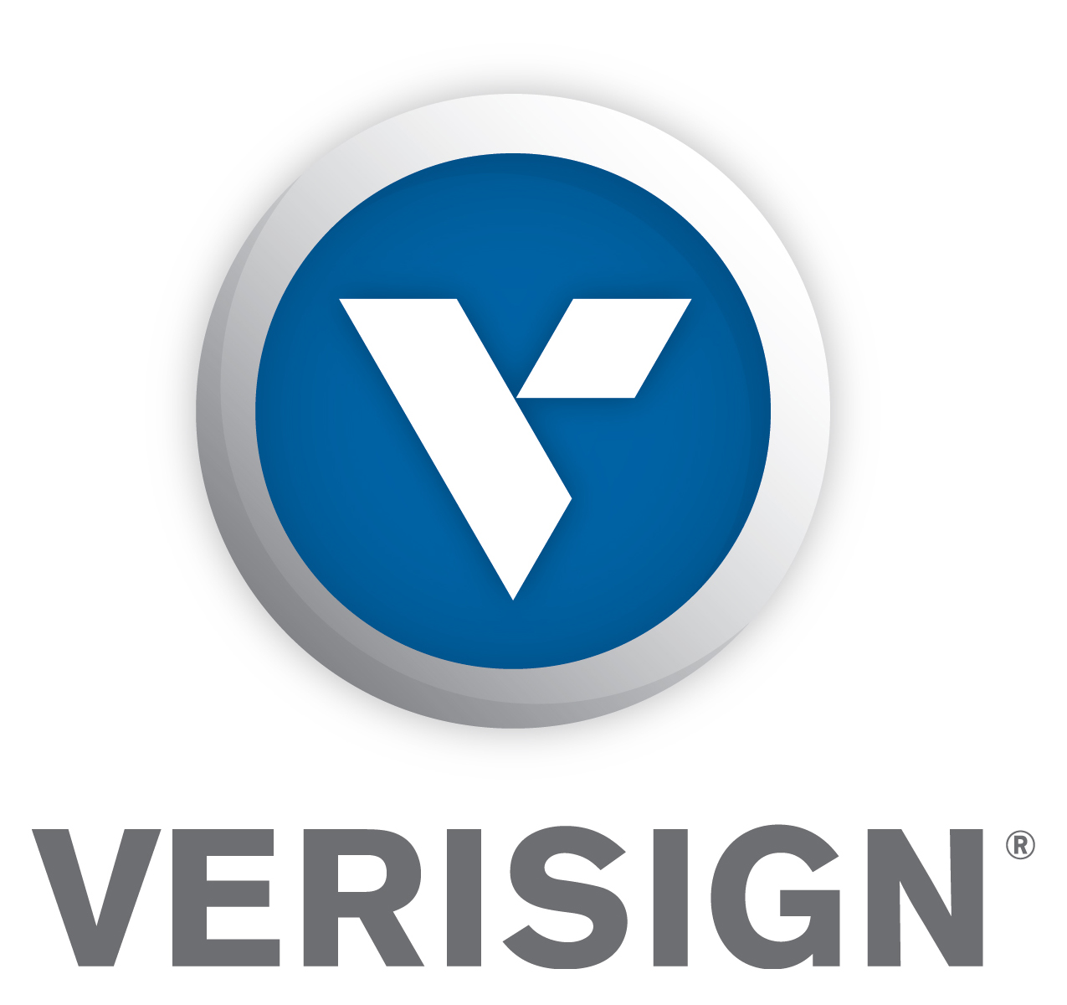

Verisign Reports Second Quarter 2026 Results

RESTON, VA - July 23, 2026 - VeriSign, Inc. (NASDAQ: VRSN), a global provider of critical internet infrastructure and domain name registry services, today reported financial results for the second quarter of 2026.

VeriSign, Inc. and its subsidiaries (“Verisign”) reported revenue of $435 million for the second quarter of 2026, up 6.0 percent from the same quarter in 2025. Operating income was $296 million for the second quarter of 2026, compared to $281 million for the same quarter of 2025. Verisign reported net income of $217 million and diluted earnings per share (diluted “EPS”) of $2.38 for the second quarter of 2026, compared to net income of $207 million and diluted EPS of $2.21 for the same quarter of 2025.

“Last week we extended our record of delivering 100% availability for the .com and .net domain name resolution system to 29 years, an unparalleled record. Today’s digital economy is increasingly reliant on this infrastructure, and the continuing strength in new domain name registrations reflects this. We delivered solid financial results in the quarter, returning more than 100% of our free cash flow to the investing public through dividends and share repurchases, which we do consistently. We are also raising our guidance for full-year 2026,” said Jim Bidzos, Executive Chairman, President and Chief Executive Officer. “We are also pleased that the .web TLD has been delegated, and we look forward to offering .web domains through our registrar channel later this year.
Financial Highlights

•Verisign ended the second quarter of 2026 with cash, cash equivalents and marketable securities of $1.03 billion, an increase of $454 million from year-end 2025.
•On June 26, 2026, Verisign issued $550 million aggregate principal amount of 5.10% Senior Notes due 2031. On July 20, 2026, the net proceeds from the issuance, together with cash on hand, were used to redeem the $550 million, 4.75% Senior Notes due 2027.
•Cash flow from operations was $232 million for the second quarter of 2026, compared to $202 million for the same quarter of 2025.
•Deferred revenues as of June 30, 2026, totaled $1.45 billion, an increase of $64 million from year-end 2025.
•During the second quarter of 2026, Verisign repurchased 0.7 million shares of its common stock for an aggregate cost of $197 million.
•Effective July 23, 2026, the Board of Directors approved an additional authorization for share repurchases of approximately $884 million of common stock, which brings the total amount to $1.50 billion authorized and available under Verisign’s share repurchase program which has no expiration.
•On July 20, 2026, Verisign’s Board of Directors approved a cash dividend of $0.81 per share of Verisign’s outstanding common stock to stockholders of record as of the close of business on August 19, 2026, payable on August 27, 2026.

Business Highlights
•Verisign ended the second quarter of 2026 with 179.1 million .com and .net domain name registrations in the domain name base, a 5.1 percent increase from the end of the second quarter of 2025, and a net increase of 3.05 million domain names during the second quarter of 2026.
•During the second quarter of 2026, Verisign processed 12.7 million new domain name registrations for .com and .net, compared with 10.4 million for the second quarter of 2025.
•The final .com and .net renewal rate for the first quarter of 2026 was 76.3 percent compared to 75.5 percent for the same quarter of 2025. Renewal rates are not fully measurable until 45 days after the end of the quarter.
•The .web top-level domain has been delegated into the global Domain Name System’s (DNS) root zone, with Verisign as the designated registry operator as announced yesterday in the company’s news release.

Today’s Conference Call
Verisign will host a live conference call today at 4:30 p.m. (EDT) to review the second quarter 2026 results. The call will be accessible by direct dial at (888) 676-VRSN (U.S.) or (646) 769-9200 (international), conference ID: Verisign. A listen-only live web cast of the conference call and accompanying slide presentation will also be available at https://investor.verisign.com. An audio archive of the call will be available at https://investor.verisign.com/events.cfm. This news release and the financial information discussed on today’s conference call are available at https://investor.verisign.com.

About Verisign
Verisign (NASDAQ: VRSN), a global provider of critical internet infrastructure and domain name registry services, enables internet navigation for many of the world’s most recognized domain names. Verisign helps enable the security, stability, and resiliency of the Domain Name System and the internet by providing root zone maintainer services, operating two of the 13 global internet root servers, and providing registration services and authoritative resolution for the .com and .net top-level domains, which support the majority of global e-commerce. To learn more please visit verisign.com.

Statements in this announcement other than historical data and information constitute forward-looking statements within the meaning of Section 27A of the Securities Act of 1933 as amended and Section 21E of the Securities Exchange Act of 1934 as amended. These statements involve risks and uncertainties that could cause our actual results to differ materially from those stated or implied by such forward-looking statements. The potential risks and uncertainties include, among others, attempted security breaches, cyber-attacks, and DDoS attacks against our systems and services; the introduction of undetected or unknown defects in our systems or services; vulnerabilities in the global routing system; system interruptions or system failures; damage or interruptions to our data centers, data center systems or resolution systems; risks arising from our operation of root servers and our performance of the Root Zone Maintainer functions; any loss or modification of our right to operate the .com and .net gTLDs; changes or challenges to the pricing provisions of the .com Registry Agreement; new or existing governmental laws and regulations in the U.S. or other applicable non-U.S. jurisdictions; new laws, regulations, directives or ICANN policies that require us to obtain and maintain personal information of registrants; economic, legal, regulatory, and political risks associated with our international operations; unfavorable changes in, or interpretations of, tax rules and regulations; risks from the implementation of ICANN’s consensus and temporary policies, technical standards and other processes; the weakening of, or changes to, the multi-stakeholder model of internet governance; the outcome of claims, lawsuits, audits or investigations; challenging economic conditions; our ability to compete in the highly competitive business environment in which we operate; changes in internet practices and behavior and the adoption of substitute technologies, or the negative impact of wholesale price increases; our ability to expand our services into developing and emerging economies; our ability to maintain strong relationships with registrars and their resellers; our ability to attract, retain and motivate highly skilled employees; the continuity of our quarterly dividend; our ability to protect and enforce our intellectual property rights; challenges from the use of AI technology by third-parties or us; and the impact on our stock price from the dissemination of false or misleading information by unrelated third parties. More information about potential factors that could affect our business and financial results is included in our filings with the SEC, including in our Annual Report on Form 10-K for the year ended Dec. 31, 2025 and subsequent Quarterly Reports on Form 10-Q and Current Reports on Form 8-K. Verisign undertakes no obligation to update any of the forward-looking statements after the date of this announcement.

Contacts
Investor Relations: David Atchley, datchley@verisign.com, 703-948-3447
Media Relations: David McGuire, davmcguire@verisign.com, 703-948-3800

©2026 VeriSign, Inc. All rights reserved. VERISIGN, the VERISIGN logo, and other trademarks, service marks, and designs are registered or unregistered trademarks of VeriSign, Inc. and its subsidiaries in the United States and in foreign countries. All other trademarks are property of their respective owners.

VERISIGN, INC.
CONDENSED CONSOLIDATED BALANCE SHEETS
(In millions, except par value)
(Unaudited)
 |  |  | June 30,  2026 |  |  |  |  |  | December 31,  2025
ASSETS
Current assets:
Cash and cash equivalents |  |  | $ | 840.9 |  |  |  |  | $ | 307.9
Marketable securities |  |  | 193.2 |  |  |  |  |  | 272.6
Other current assets |  |  | 88.2 |  |  |  |  |  | 72.0
Total current assets |  |  | 1,122.3 |  |  |  |  |  | 652.5
Property and equipment, net |  |  | 227.7 |  |  |  |  |  | 213.7
Goodwill |  |  | 52.5 |  |  |  |  |  | 52.5
Deferred tax assets |  |  | 223.0 |  |  |  |  |  | 233.2
Deposits to acquire intangible assets |  |  | 145.2 |  |  |  |  |  | 145.2
Other long-term assets |  |  | 32.1 |  |  |  |  |  | 28.8
Total long-term assets |  |  | 680.5 |  |  |  |  |  | 673.4
Total assets |  |  | $ | 1,802.8 |  |  |  |  | $ | 1,325.9
LIABILITIES AND STOCKHOLDERS’ DEFICIT
Current liabilities:
Accounts payable and accrued liabilities |  |  | $ | 265.0 |  |  |  |  | $ | 298.0
Deferred revenues |  |  | 1,084.8 |  |  |  |  |  | 1,035.1
Current senior notes |  |  | 549.3 |  |  |  |  |  | —
Total current liabilities |  |  | 1,899.1 |  |  |  |  |  | 1,333.1
Long-term deferred revenues |  |  | 364.1 |  |  |  |  |  | 349.4
Long-term senior notes |  |  | 1,785.1 |  |  |  |  |  | 1,788.2
Long-term tax and other liabilities |  |  | 8.6 |  |  |  |  |  | 9.4
Total long-term liabilities |  |  | 2,157.8 |  |  |  |  |  | 2,147.0
Total liabilities |  |  | 4,056.9 |  |  |  |  |  | 3,480.1
Commitments and contingencies
Stockholders’ deficit:
Preferred stock—par value $.001 per share; Authorized shares: 5.0; Issued and outstanding shares: none |  |  | — |  |  |  |  |  | —
Common stock and additional paid-in capital—par value $.001 per share; Authorized shares: 1,000; Issued shares: 355.9 at June 30, 2026 and 355.6 at December 31, 2025; Outstanding shares: 90.4 at June 30, 2026 and 91.9 at December 31, 2025 |  |  | 9,092.7 |  |  |  |  |  | 9,623.5
Accumulated deficit |  |  | (11,344.0) |  |  |  |  |  | (11,775.0)
Accumulated other comprehensive loss |  |  | (2.8) |  |  |  |  |  | (2.7)
Total stockholders’ deficit |  |  | (2,254.1) |  |  |  |  |  | (2,154.2)
Total liabilities and stockholders’ deficit |  |  | $ | 1,802.8 |  |  |  |  | $ | 1,325.9

VERISIGN, INC.
CONDENSED CONSOLIDATED STATEMENTS OF COMPREHENSIVE INCOME
(In millions, except per share data)
(Unaudited)
 |  |  | Three Months Ended June 30, |  |  |  |  |  |  |  |  |  |  |  | Six Months Ended June 30,
 |  |  | 2026 |  |  |  |  |  | 2025 |  |  |  |  |  | 2026 |  |  |  |  |  | 2025
Revenues |  |  | $ | 434.6 |  |  |  |  | $ | 409.9 |  |  |  |  | $ | 863.5 |  |  |  |  | $ | 812.2
Costs and expenses:
Cost of revenues |  |  | 50.0 |  |  |  |  |  | 49.1 |  |  |  |  |  | 99.2 |  |  |  |  |  | 98.5
Research and development |  |  | 27.5 |  |  |  |  |  | 25.7 |  |  |  |  |  | 55.0 |  |  |  |  |  | 51.7
Selling, general and administrative |  |  | 60.8 |  |  |  |  |  | 54.4 |  |  |  |  |  | 119.4 |  |  |  |  |  | 110.1
Total costs and expenses |  |  | 138.3 |  |  |  |  |  | 129.2 |  |  |  |  |  | 273.6 |  |  |  |  |  | 260.3
Operating income |  |  | 296.3 |  |  |  |  |  | 280.7 |  |  |  |  |  | 589.9 |  |  |  |  |  | 551.9
Interest expense |  |  | (19.2) |  |  |  |  |  | (18.9) |  |  |  |  |  | (38.1) |  |  |  |  |  | (39.2)
Non-operating income, net |  |  | 4.5 |  |  |  |  |  | 5.5 |  |  |  |  |  | 9.2 |  |  |  |  |  | 13.0
Income before income taxes |  |  | 281.6 |  |  |  |  |  | 267.3 |  |  |  |  |  | 561.0 |  |  |  |  |  | 525.7
Income tax expense |  |  | (65.1) |  |  |  |  |  | (59.9) |  |  |  |  |  | (130.0) |  |  |  |  |  | (119.0)
Net income |  |  | 216.5 |  |  |  |  |  | 207.4 |  |  |  |  |  | 431.0 |  |  |  |  |  | 406.7
Other comprehensive loss |  |  | — |  |  |  |  |  | — |  |  |  |  |  | (0.1) |  |  |  |  |  | (0.3)
Comprehensive income |  |  | $ | 216.5 |  |  |  |  | $ | 207.4 |  |  |  |  | $ | 430.9 |  |  |  |  | $ | 406.4
Earnings per share:
Basic |  |  | $ | 2.38 |  |  |  |  | $ | 2.21 |  |  |  |  | $ | 4.73 |  |  |  |  | $ | 4.32
Diluted |  |  | $ | 2.38 |  |  |  |  | $ | 2.21 |  |  |  |  | $ | 4.71 |  |  |  |  | $ | 4.31
Shares used to compute earnings per share
Basic |  |  | 90.8 |  |  |  |  |  | 93.8 |  |  |  |  |  | 91.2 |  |  |  |  |  | 94.2
Diluted |  |  | 91.1 |  |  |  |  |  | 94.0 |  |  |  |  |  | 91.4 |  |  |  |  |  | 94.4

VERISIGN, INC.
CONDENSED CONSOLIDATED STATEMENTS OF CASH FLOWS
(In millions)
(Unaudited)
 |  |  | Six Months Ended June 30,
 |  |  | 2026 |  |  |  |  |  | 2025
Cash flows from operating activities:
Net income |  |  | $ | 431.0 |  |  |  |  | $ | 406.7
Adjustments to reconcile net income to net cash provided by operating activities:
Depreciation of property and equipment |  |  | 13.0 |  |  |  |  |  | 17.2
Stock-based compensation expense |  |  | 38.5 |  |  |  |  |  | 33.4
Other, net |  |  | (1.7) |  |  |  |  |  | (3.4)
Changes in operating assets and liabilities:
Other assets |  |  | (19.7) |  |  |  |  |  | (19.9)
Other liabilities |  |  | (31.8) |  |  |  |  |  | (24.8)
Deferred revenues |  |  | 64.5 |  |  |  |  |  | 75.5
Net deferred income taxes |  |  | 10.2 |  |  |  |  |  | 9.1
Net cash provided by operating activities |  |  | 504.0 |  |  |  |  |  | 493.8
Cash flows from investing activities:
Proceeds from maturities and sales of marketable securities |  |  | 274.2 |  |  |  |  |  | 396.8
Purchases of marketable securities |  |  | (192.2) |  |  |  |  |  | (278.6)
Purchases of property and equipment |  |  | (26.0) |  |  |  |  |  | (13.6)
Net cash provided by investing activities |  |  | 56.0 |  |  |  |  |  | 104.6
Cash flows from financing activities:
Proceeds from senior note issuance, net of issuance costs |  |  | 546.4 |  |  |  |  |  | 493.3
Repurchases of common stock |  |  | (426.8) |  |  |  |  |  | (408.5)
Payment of dividends |  |  | (147.8) |  |  |  |  |  | (72.1)
Proceeds from employee stock purchase plan |  |  | 8.5 |  |  |  |  |  | 7.9
Payment of excise tax on repurchase of common stock |  |  | (7.9) |  |  |  |  |  | (11.6)
Repayment of borrowings |  |  | — |  |  |  |  |  | (500.0)
Net cash used in financing activities |  |  | (27.6) |  |  |  |  |  | (491.0)
Effect of exchange rate changes on cash, cash equivalents, and restricted cash |  |  | 0.6 |  |  |  |  |  | 0.1
Net increase in cash, cash equivalents, and restricted cash |  |  | 533.0 |  |  |  |  |  | 107.5
Cash, cash equivalents, and restricted cash at beginning of period |  |  | 309.5 |  |  |  |  |  | 212.1
Cash, cash equivalents, and restricted cash at end of period |  |  | $ | 842.5 |  |  |  |  | $ | 319.6
Supplemental cash flow disclosures:
Cash paid for interest |  |  | $ | 36.4 |  |  |  |  | $ | 42.3
Cash paid for income taxes, net of refunds received |  |  | $ | 125.5 |  |  |  |  | $ | 149.4

